OH! Open House Volunteers
Art 101 & 102
Configured for Remote Training

Art 101

Welcome to Art 101 training 👋
We’ll learn the basics of interpreting and sharing about an artwork using SEE-THINK-WONDER. It’s a powerful thinking routine for encountering artworks. Art 101 focuses on SEE and THINK. Art 102 delves into WONDER.

Here’s what we’ll be covering:
- What is SEE-THINK-WONDER?
- SEEing an artwork
- THINKing about an artwork
- Sharing with an audience

Let’s begin!

What is SEE-THINK-WONDER?

SEE-THINK-WONDER is a thinking routine that helps you make better sense of visual artworks by looking at, developing interpretations of, and asking insightful questions about them.

1. SEE 👀
1. a) What is SEE? 👀
- As the first step of the thinking routine, SEE focuses on looking closely at an artwork to recognize the visual choices made by the artist in creating the artwork
- In Art History terms, SEE is also known as Visual Analysis

1. b) What is there to SEE?
- All artworks are made up of various kinds of building blocks
- A good entry point into the artist’s visual choices is to break down the artwork into these building blocks and figure out how the artist uses them
- These building blocks are also known as the Formal Elements of Art
- When these formal elements are combined, they form a Composition

Formal Elements of Art:
Element | Definition | Words to Describe
Line | A one dimensional path of a point through space | Thick or thin, bold or fine, curved or straight, solid or dotted, long or short
Shape | 2-dimensional elements formed when lines join | Organic or geometric, big or small
Form | 3-dimensional shapes | Spheres, cylinders, cubes, regular, irregular
Space | Area around and within objects/forms/lines | Positive space––area occupied by elements  Negative space––area unoccupied by elements
Colour | (Literally, the colour. E.g. maroon, periwinkle, bright green) | Vivid, muted, warm, cool, varied, monochrome, contrasting
Texture | Surface quality of an artwork which can be seen or felt | Smooth, rough, hard, soft, matte, glossy, delicate, coarse, uniform, granular, silky, sandy
Value | The degree of lightness or darkness of a colour | Colours that contain the most white and are one the paler/lighter end of the gradient are “high key” colours. Colours that contain the most black and are on the darker end of the gradient scale are “low key” colours

1. c) Why SEE?
- By observing the separate building blocks of the art object, we can come to a better understanding of the art object as a whole
- When presented with an artwork, a common tendency is to jump to a conclusion about it (e.g. “I don’t like it”) without being able to explain why…But, by closely observing a work, we ensure that any conclusions we make are 1) generous to the work and the artist, and 2) well-substantiated.

1.d) How to SEE?
Exercise 1: Observation
1. For at least 1 minute, look at the image of Artwork A below Let your eyes wander all over the work.
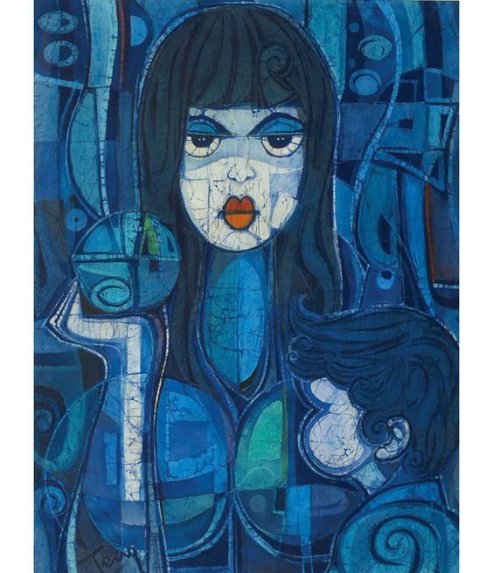
Click here to open the image in a new tab.
2. List 10 words or phrases about any aspect of the artwork in the space below.

3. Now, look at the image of Artwork A again and describe the colours, shapes, and lines in the artwork in detail. Fill in the blanks in the table.

COLOURS : What colours do you see? Describe them. | SHAPES: What shapes do you see? Describe them. | LINES: What lines do you see? Describe them.
e.g. In Van Gogh’s Starry Night, there are many different shades of blue in the background, ranging from light blue to dark blue. In some of the light blue swirls, there are specks of yellow, and also yellow circles in the otherwise dark background.

2. THINK 🧠
Having made our observations of the artwork, we can now move to the next step, THINK.

2.a) What is THINK?
- THINK is the process of developing a substantiated interpretation of an artwork
- In this step, we move from recognising the artist’s visual choices to attempting to understand these choices. In other words, we move from making observations to making claims about the artwork

2.b) How to THINK?
- Trying to formulate a big claim about an artwork might seem daunting, but having SEEn the artwork, we have a back pocket of observations we can use as a starting point (Any claims we make should be well-supported so we should avoid making claims without having an observation to back it up!)
- Recalling the Formal Elements, we can use our previous observations of them to consider how they affect the work

Element | To Consider
Line | Do the lines connect or divide the elements? Where do the lines lead your eye? Do they bring attention or divert your attention to any of the elements?
Shape | Are the shapes symbolic of anything? How are the shapes organised?
Form | How were the forms made? Were they modelled, carved, or constructed? Are the forms symbolic of anything?
Space | Are objects spaced close together or far apart? Might the spaces between objects signal their relationships to each other?
Colour | What atmosphere or emotion is evoked by the colours?
Texture | How was the texture created? Does it arise through the paint, quality of objects or materials? What sensations are created by the textures?
Value | Does the work feature colours that are similar in value (perhaps very light, or very dark)? Does the work play with contrasts - for instance by putting colours with opposite values together? Or does it have little contrast, with colours of similar values put together.

Let’s try!

Exercise 2: From Observation to Interpretation

Look back at your table from Exercise 1 Question 3. Choose a kind of colour, space, or line that you listed. How does it contribute to the artwork overall? (How does it help the artwork “work?”)

Consider:
How does it contribute to how the artwork feels?
How does it contribute to the mood of the artwork?
How does it contribute to how the artwork looks?

*Do this with at least two elements. They can be chosen from any column. Write your response in the table below.

Element | Observation  (Copy from Exercise 1) | Contribution to Artwork
E.g. Colour | In Van Gogh’s Starry Night, there are many different shades of blue in the background, ranging from light blue to dark blue. In some of the light blue swirls, there are specks of yellow, and also yellow circles in the otherwise dark background | The dominant use of blue creates a rather melancholic and moody atmosphere that is contrasted by the littering of yellow, that lighten the mood.

2.b) How to THINK?
- These interpretations of our observations (i.e. sub-claims about the artwork) can now be considered holistically to formulate a Main Claim
- Rather than focusing on a specific formal element, a main claim should reflect on the overall organisation of the artwork
- One way to approach this step is to imagine yourself responding to the question “What do you think is going on in the artwork?”.
- In response, you could pick up on one of the following aspects of an artwork to form the point of your main claim:

- Subject matter
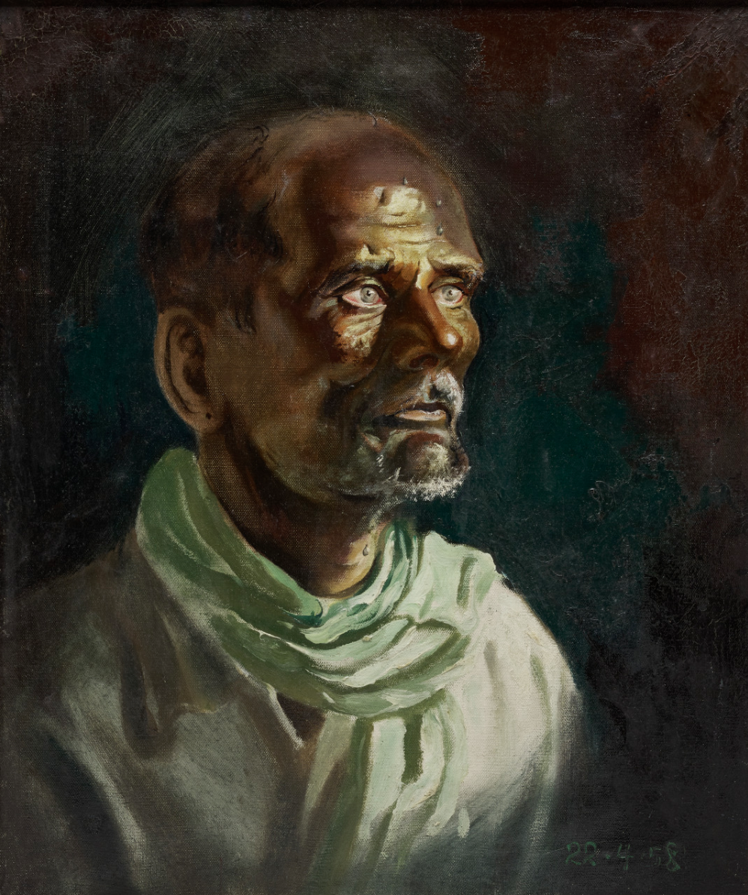 | Tay Boon Pin’s painting, Portrait of an Indian Worker, depicts a brooding and exhausted labourer.

- Thematic concern
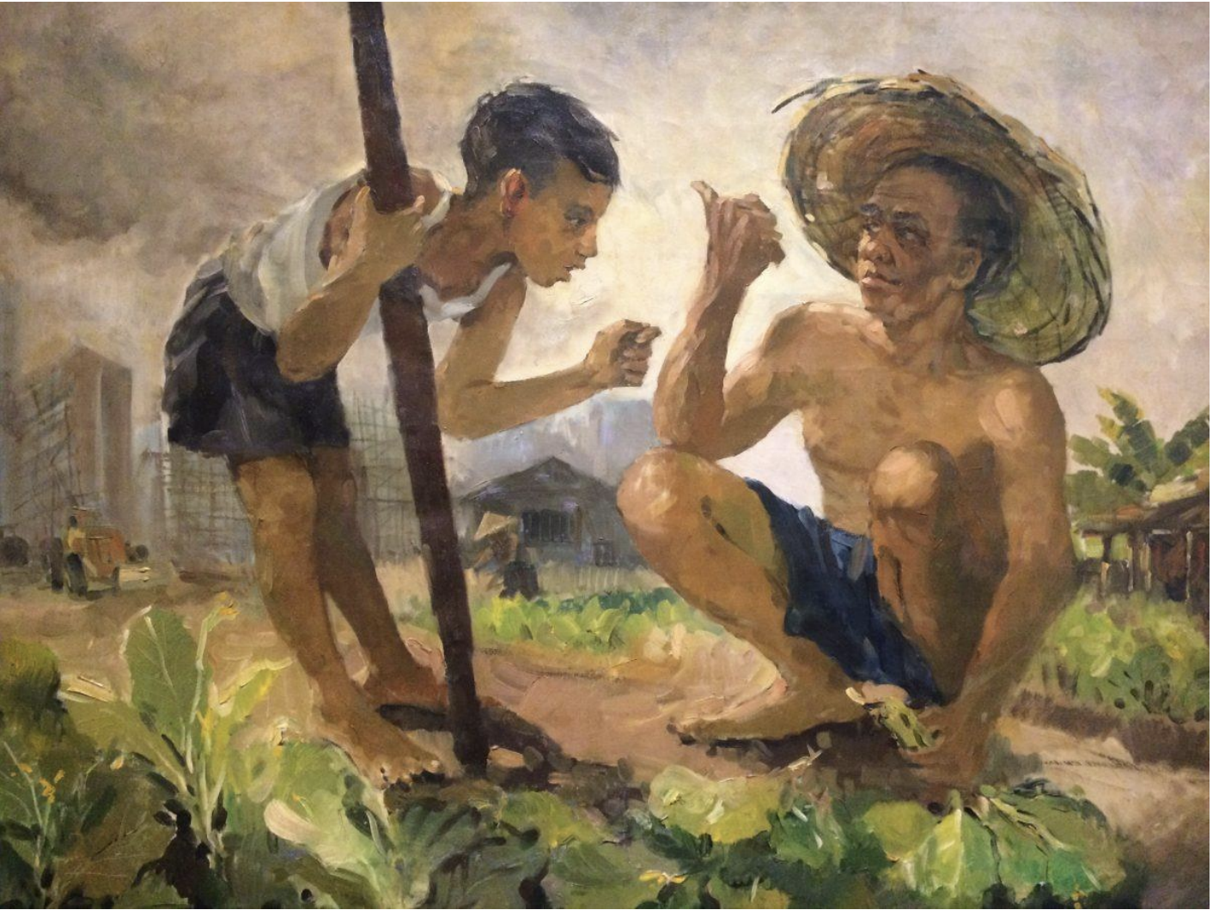 | Koeh Sia Yong’s Cannot Grow Vegetables Anymore invites audiences to consider the detrimental effects of urbanisation.

- Artistic medium
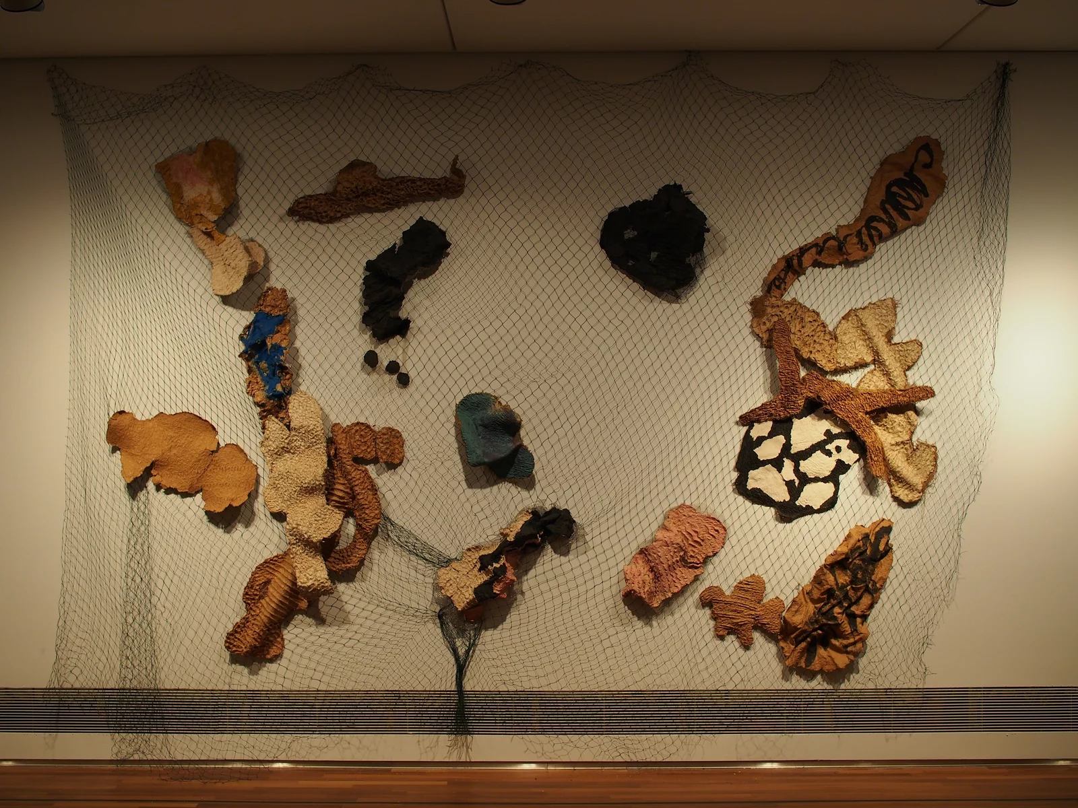 | Teo Eng Seng’s work The Net: Most Definitely the Singapore River, offers a unique take on the image of the Singapore River, a common subject in Singaporean art, through the use of a unique technique invented by the artist himself called ‘paperdyesculp’, in which dyed papier-mache is shaped into artworks.

Exercise 3: Interpretation
Refer to Artwork A for the following questions. Click here to reopen the artwork image in a new tab.

1. What might be going on in the artwork? Type your response in the space below.

2. What do you see that makes you say that? (Refer to your table in Exercise 1 to help you!) Type your response in the space below.

3. SHARING WITH AN AUDIENCE 💁🏽
As guides, our job isn’t only to interpret artworks but also to share about them effectively. For that, we’ll take a break from SEE-THINK-WONDER and explore another framework, PEEL.

PEEL is an acronym which stands for Point, Evidence, Explanation, Link. Here’s how we might employ PEEL in relation to an artwork.

 | Task | Guiding Question | Relevant Exercise
Point | State your main claim about the artwork | What might be going on in the artwork? | Exercise 3
Evidence  (Visual) | Support your claim with observable details | What do you see that makes you say that? | Exercise 1
Explanation | Elaborate on how the observable details helped you formulate your claim | How did the observable details make the work “work”? | Exercise 2
Link | Reinforce your claim | What should audiences take away after your sharing?

Refer to the PEEL paragraph below about Artwork B for an example.

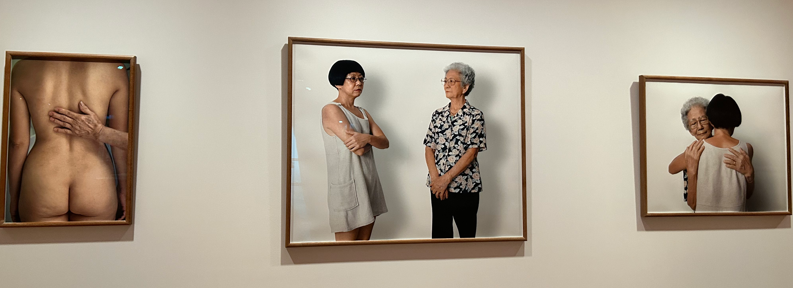
Artwork B

Artwork B explores the relationship between two women, who are perhaps mother and daughter, through three photographs. Each photograph captures the closeness or distance between the two women, as they occupy different positions relative to each other.

The two women featured in the artwork appear to be related as they bear some resemblance to each other, but are also distinctly different in terms of ways in which they present themselves. There is an age gap between them, for one woman is visibly younger, and wears modern clothing, while the other is older, with greying hair and an old fashioned outfit. There also appears to be an emotional distance between the women. In the image in the middle, the older woman looks towards the younger one, who does not reciprocate. Their body language also appears stiff and guarded. Because of these physical distances, there appears to be a distance between the two women that cannot be bridged. Another image depicts the nude figure of the younger woman, with the older woman’s hand gently holding her back. The image evokes a gesture of comfort, of support, offered by the older woman. But this gesture is once again, not reciprocated by the younger woman. The final image shows the two women embracing. The older woman’s body language has softened, she has her eyes closed as she embraces the younger woman. Again, we can only see the back of the younger woman, who is returning the hug, but we remain uncertain of how she feels about this moment of connection as we cannot see her face.

Through the three different images, the work appears to be tracing the shifting nature of the relationship between the two women, revealing the changing physical and emotional closeness between mother and daughter.

Exercise 4: PEEL
Imagine that you are tasked with sharing about Artwork A with an audience. Prepare for your sharing by structuring your responses from the previous Exercises into the PEEL format. Type your finished PEEL paragraph in the table below.

My Response
Point
Evidence
(Visual)
Explanation
Link

4. Conclusion
Congratulations, you’ve completed Art 101! We learned how to…
- SEE: Look at an artwork closely and accumulate observations of its formal elements
- THINK: Develop interpretations of these observations into sub-claims and a main claim
- Share these claims through the PEEL structure

Remember to email your completed worksheet to volunteer@ohopenhouse.org so we can leave you feedback.

Thank you for completing this training!

